**Award:**  Engineers Ireland Excellence Awards

**Category:** Local Authority Engineering Initiative Award

**Local Authority:** Cork County Council

**Project:** Garrettstown Beach Coastal Protection Works

**Executive Summary**

The winter of 2013/14 was severely affected by an exceptional run of winter storms, culminating in serious coastal damage and widespread persistent flooding. A combination of strong winds, tidal surges and low pressure conspired to cause widespread damage. Peak wave periods were unusually long and record wave heights culminated in severe flooding and widespread damage. Storm force winds occurred on twelve different days, with Kinsale Energy Gas Platform recorded a maximum wave height of 25m, its highest on record.

Garrettstown beach is approximately 2km of sandy beach located approximately 9km south of Kinsale. The beach has sea walls, gabion baskets, rock armour and embankments all performing as coastal protection measures. During the storms of 2014 the gabion baskets suffered severe damage and alternative coastal protection measures had to be investigated.

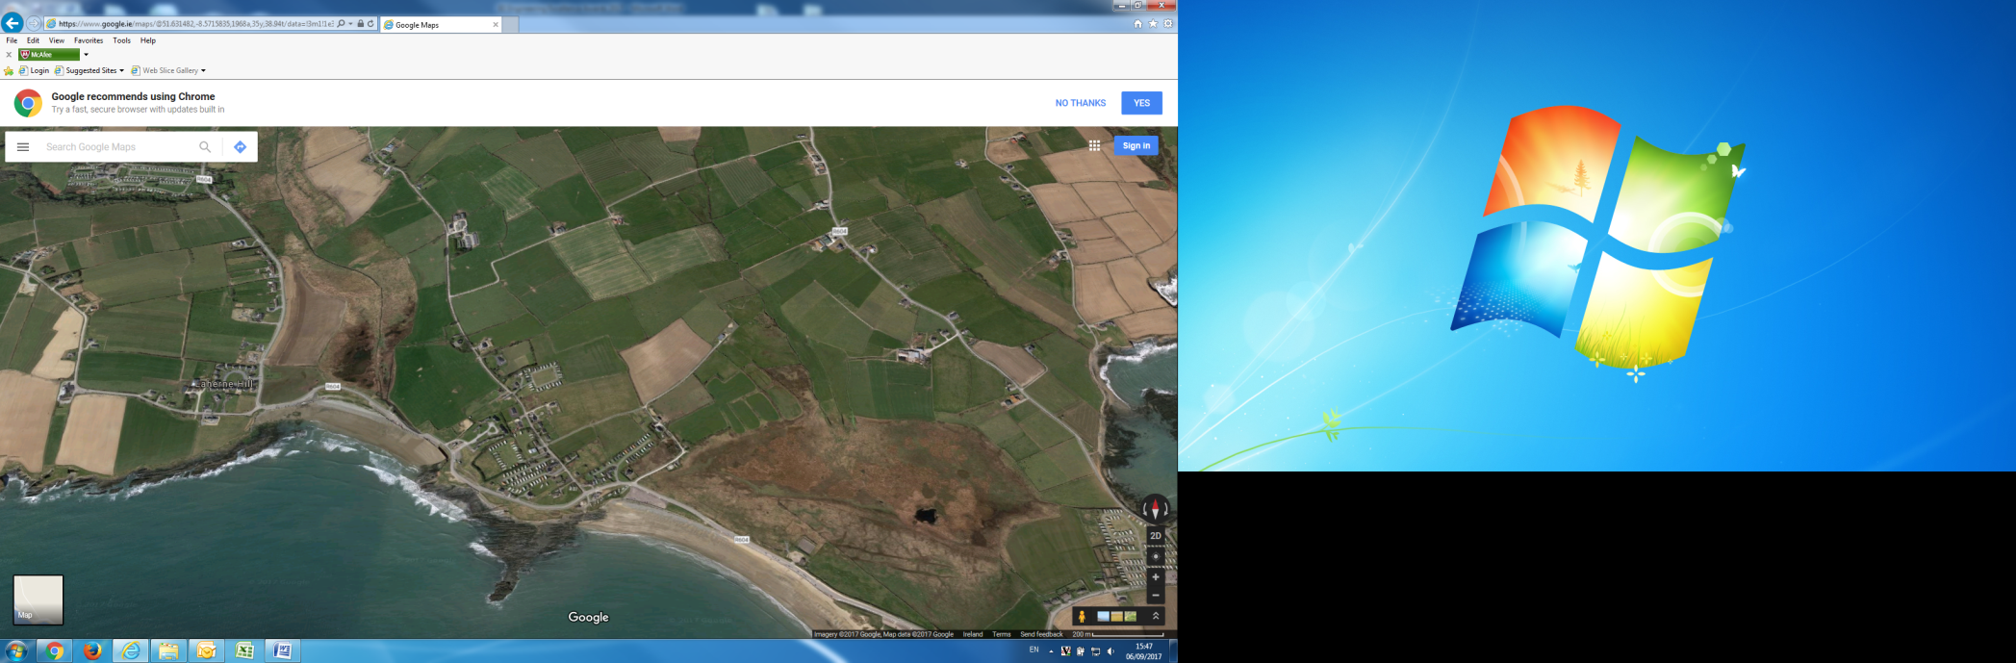

**Garrettstown Beach**

Initial trials of this erosion control product were carried out in the late 1990’s by University College Cork and revetments were constructed in Tawin Island, Co. Galway and Achill Island, Co. Mayo. Now with the involvement of Cork based company Erosion Control Protection Solutions Ltd. (ECPS Ltd.) and major laboratory trials at the Centre for Marine and Renewable Energy, UCC under the supervision of Dr. Jimmy Murphy the product has been further developed to its current design. This product was identified as a viable alternative to traditional rock armour in addressing the challenges of severe coastal erosion damage.

The benefits of the new technology are as follows:

* They are regular in shape, therefore easy to manufacture, transport and place on site;
* They are bulky such that the units have a high structural strength and are capable of withstanding all loading types;
* They are interlocking such that the units exhibit good hydraulic stability;
* They are hollow to reduce unit costs and increase the stability. It has been found that armour layers with higher porosities are more stable and less likely to fail.
* They are suitable for Irish conditions and are versatile such that they can be used for a variety of applications.

In choosing this technology Cork County Council have become early adopters of this revolutionary technology. The Garrettstown Beach Coastal Protection Works was completed in June 2017.

**\*NOTE:** – The Project Team consisted of the following:

* Cork County Council – Coastal Management & Flood Projects Section
* Erosion Control Protection Solutions Ltd.
* UCC – Centre for Marine and Renewable Energy
* Regan Construction

**Use of Sound Engineering Principles and Practices**

The coastline is a dynamic interface between land and sea that is continuously adjusting to cope with environmental and astronomical forces. Therefore both erosion and accretion are part of the natural processes that have been shaping our coastline for centuries. Although coastal protection works are nothing new there does seem to be an increasing demand and necessity for such works in recent times.

There are a variety of protection measures/structures currently in use. They include hard (seawalls, vertical revetments), semi hard (sloping revetment, rock groynes, gabion structures) and soft (beach nourishment, dune re-contouring, grass planting) type structures. A vast number of armour block designs exist for protection of breakwaters and coastal structures, many of which have very complicated shapes which were found to be very difficult to fabricate, to transport and also very fragile when placed on the structure.

When designing a new type of concrete armour block the following basic criteria should be satisfied:

* The block should have a high structural strength and be able to withstand all conceivable loading scenarios.
* The block should exhibit good hydraulic stability. This relates to the ability of the unit to resist wave forces. A low stability factor means a heavier unit would be required thus increasing the cost of the protection structure.
* The placement pattern should result in the armour layer having a high porosity. It has been found that armour layers with higher porosities are more stable and less likely to fail.

The Erosion Control Armour Block (ECAB) was developed to respond to these requirements with the resulting unit to be:

* Easy and cheap to manufacture, transport and place.
* Bulky such that the units have a high structural strength.
* Interlocking such that the unit exhibits good hydraulic stability.
* Hollow blocks to reduce unit costs and increase stability through its high porosity characteristics.
* Regular in shape such that they can be placed in a single layer to a uniform pattern.
* Suitable to Irish conditions.
* Versatile such that they can be used for a variety of applications.

The ECAB block were trialled and tested in the UCC Hydraulics and Maritime Research Centre (HMRC) now known as the Centre for Marine and Renewable Energy (MaREI) in Ringaskiddy, Co. Cork. Earlier designs were installed in two areas in the West of Ireland in the late 1990’s, namely Tawin Island in Galway and Achill Island in Mayo.

Erosion Control Protection Solutions Ltd. (ECPS Ltd.) a Cork based company formed in 2013 specialises in providing an alternative coastal erosion solution to rock armour. ECPS Ltd. have strengthened the technical side of the product by conducting various tests in UCC’s MaREI building with the help of Enterprise Ireland in 2015 and again in 2016 using 1/30th scale models. The tests involve subjecting these ECAB scale models to different wave heights and wave periods to measure the stability of the ECABS and also to measure overtopping and reflection. The ECABS have performed very well surviving in some cases waves of the equivalent of above 5 meters.

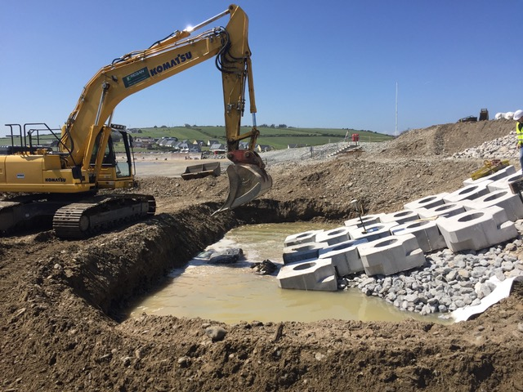

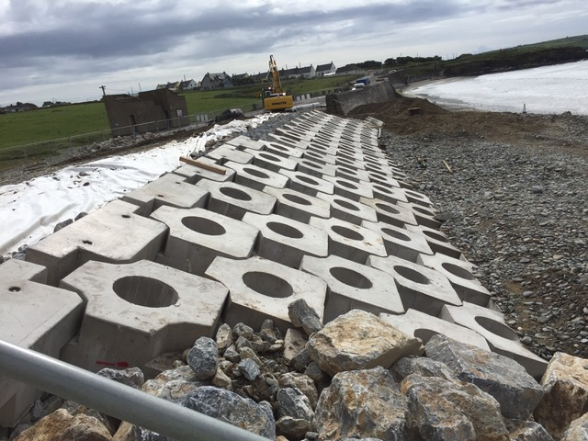

**Impact of the work on the quality of life of the relevant communities**

The vision for Garrettstown in the recently published Bandon Kinsale Municipal District Local Area Plan is to support its development as a multi-use water sport area, improve public amenity and recreation facilities, protect the unique natural heritage, ecology and high value landscape of the coastal settlement and to allow for small scale development which would not injure this sensitive landscape and ecological environment.

The ECAB coast protection system is an innovative, sustainable and cost effective solution to coastal erosion. From an aesthetic point of view the ECAB is manufactured from a blend of Ordinary Portland Cement, OPC and Ground Granulated Blast Furnace slag, GGBS (a by product of the steel industry). In contrast to the stony grey of concrete made with OPC, GGBS cement allows the concrete to achieve a lighter colour finish; it is a more environmentally friendly, stronger and more durable concrete. The lighter colour allows the ECAB blocks to match the local sands and the voids allow indigenous vegetation such as marram grass to grow between the blocks to enhance their appeal.

The ECAB revetment is designed for the local area primarily to protect the regional road (R604) from being overtopped. The results of overtopping are sand and other beach debris being strewn across the road and preventing traffic using the road. During winter time this is a common occurrence and the road is cleared repeatedly by Cork County Council at considerable expense both in time and financially.

The ECAB is essentially octagonal in shape with recesses and projections on opposite sides such that to allow adjacent blocks to interlock and so give a structure with higher resistance to movement than if each acted individually. Each block is held in place by two others. Each block is 1.3m wide, 0.55m deep and weighs approximately 1.6 tonnes. The flexibility of the interlocking points allows for slight rotation of the units thus allowing easier placement and placement around bends. This allows for the ECAB revetment to be more aesthetically pleasing as they follow the contours of the beach. The block does not contain slender elements consequently reducing the likelihood of breakages.

The ECAB contains a large central orifice, which is designed to improve the hydraulic performance. Additional porosity is achieved by the manner of placement giving an overall voids ratio of approximately 0.4 which is similar to rock revetments. The units are placed on a filter layer of granular material to absorb the ingress of water which in turn is placed on a fabric geotextile.

This type of ECAB revetment has been shown to be extremely stable when tested during storms. In contrast, rock armour boulders can be displaced in similar conditions; hence the ECAB product is safer for users of the beach than an equivalent rock armour revetment.

Intrinsic to the R&D aspect of the project is that UCC MaREI will be monitoring the performance of the ECAB revetment. Included in this is surveying and monitoring of the beach before and after installation and monitoring the performance of the ECAB revetment.

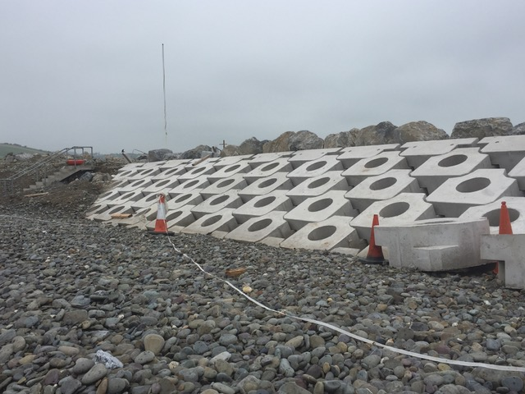

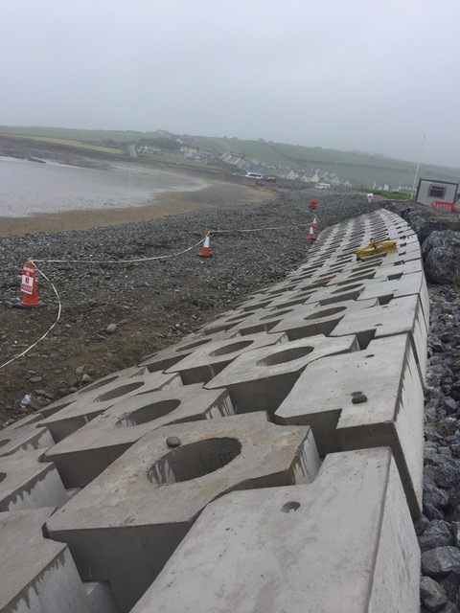

**Adherence to the budget, quality and programme**

It was recognised that Garrettstown Beach would be a very suitable location in which to trial an alternative to traditional rock armour. Furthermore, cost estimates for this ECAB product were comparable with those of rock armour.

The quality of the product supplied by ECPS Ltd. was evident from the model testing work carried out in UCC MaREI. The development/validation of a new concrete armour unit requires examining the influence that a number of different factors have on the performance of the structure. The model tests sought to examine the effects of stability, unit size, slope, run up, overtopping and reflection on the revetment when subjected to differing wave sizes and wave periods, at 1/30th scale.

The testing by UCC MaREI has shown that the ECAB revetment with a properly designed filter layer on an appropriate slope is an extremely robust armouring system for revetments and breakwaters.

Construction on site had to be programmed to coincide with low tides, which resulted in a programme of 4 weeks on site.

The contract for the ECAB revetment works was within budget and within programme. The attention to detail by all the project team to the construction quality of the revetment, notable in such elements as precast concrete and in-situ concrete has produced a product of an extremely high standard.

